<<Medical Journal Publication>>

Design document

The purpose of this document is to outline the high-level design specification of the Medical Journal system in which it presents the application objective, high-level requirement analysis and assumption, technology of choice, data model, architecture diagrams describing process, control, and data flows, and implementation overview of sub-system.

<<Medical Journal>> system is a digital eco-system allowing publishers to share medical related journals for any public user who is interested with specific subject by subscribed and read it, electronically.

**Functional Requirements**

The system allows publishing and subscribing to medical journals in a secure way. The system **must** implement the following specification:

1. For publishers
   1. A web portal to upload and manage a list of medical journals
   2. To upload journals in PDF format
2. For public users
   1. A web portal to find and subscribe to journals of their interest
   2. A desktop client;
      1. To list and read the subscribed journals
      2. That does not allow copying the journal’s content in any common way
         1. Not from web requests/response
         2. Not from their file system
         3. Not from the client use interface (copy to clipboard, screenshot, etc.)

Assumptions

The following assumptions is established to allow a simple, efficient, and secure implementation of the system:

1. User can register and/or access the system as either a *Publisher* and *Public user* role or ***both***, therefore: a user must specify their role, during register and login to Web portal
2. A journal, in addition to pdf document, should consists short notes describing context & topic and tags for easier search
3. Both *Publishers* and *Public Users* must be authenticated before using Web portal & Desktop client:
   1. To identify users in managing medical journals and subscription
   2. Securing access to web portal and protected data
   3. Fetch correct list of subscribed journal
4. Only author (publisher) of a journal can manage (list, read, update, delete) thru Web portal, therefore: copy protection feature does not apply to Web portal
5. Desktop client **allows** *Public user* read subscribed journal *offline*, and to avoid user from **copying the journal’s content** it must in encrypted form both in transit and at rest
6. User can’t have duplicate journal

**Architecture**

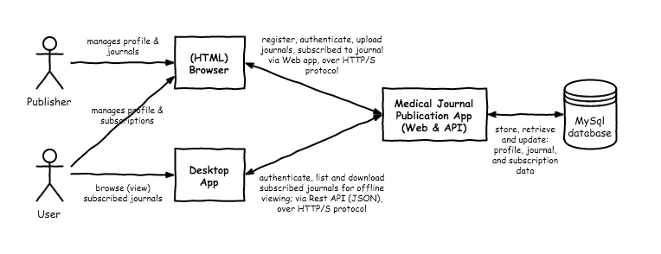

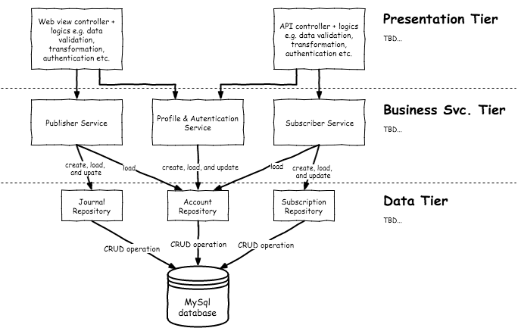

**Data Model**

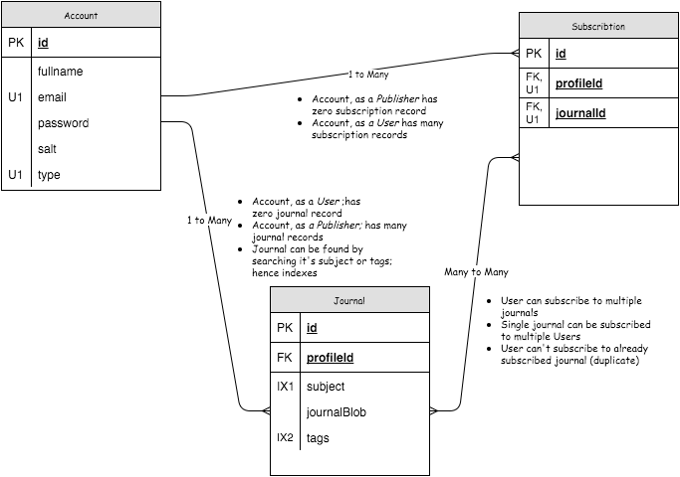

**Implementation**

Security

TBD… explain how high-level security

Use-Cases

Web Portal

Publisher

1. Registration

Happy path:

* 1. Navigate to [host]/index
  2. Registration form is rendered
  3. Enter: full name (optional); email, password, and type (all mandatory)
  4. New publisher is created, user redirect to [host]/journals

Non-happy path

* 1. Invalid email and/or password format
  2. Duplicate email

1. Login

Happy path:

* 1. Navigate to [host]/index
  2. Login form is rendered
  3. Enter: email, password, and type; all mandatory
  4. Upon successful login, user redirect to [host]/dashboard/journals

Non-happy path:

* 1. Invalid email and password

1. ***~~Reset Password~~***
2. List Journals

Happy path:

* 1. Navigate to [host]/journals
  2. Dashboard page is rendered, displaying list of journal
  3. Journal’s item: Subject, file name, and link to preview journal

Non-happy path:

1. Upload Journals

Happy path:

* 1. Navigate to [host]/dashboard/publisher
  2. Dashboard path is rendered, displaying list of journal
  3. User click “Upload” button, user redirect to [host]/journal/upload
  4. Enter: subject, tags and select local file (pdf type only) – all mandatory
  5. User click “Submit
  6. New Journal is added, user redirect back to [host]/dashboard/publisher

Non-happy path:

* 1. Missing mandatory fields
  2. File is not in pdf format
  3. Upload incomplete (connection severe or timeout)

Public User (Subscriber)

1. Registration

Happy path:

* 1. Navigate to [host]/register
  2. Registration form is rendered
  3. Enter: full name (optional); email, password, and type (all mandatory)
  4. New publisher is created, user redirect to [host]/subscriber

Non-happy path

* 1. Invalid email and/or password format
  2. Duplicate email

1. Login

Happy path:

* 1. Navigate to [host]/login
  2. Login form is rendered
  3. Enter: email, password, and type; all mandatory
  4. Upon successful login, user redirect to [host]/publisher

Non-happy path:

* 1. Invalid email and password

1. ***~~Reset Password~~***
2. List of subscribed journals

Happy path:

* 1. Navigate to [host]/subscriber
  2. Dashboard page is rendered, displaying list of subscribed journals
  3. subscribed journal’s item: Subject

Non-happy path:

1. Find Journal, by subject ***~~or tags~~***

Happy path:

* 1. Navigate to [host]/subscriber
  2. Dashboard page is rendered, displaying list of subscribed journals
  3. User enter “Search topic” (subject ***~~and/or tags~~***), click search
  4. Redirect to [host]/journal?search=
  5. Journal page is rendered with list of related journals, per search text

Non-happy path:

1. Add Journal

Happy path:

* 1. Perform “Find journal”
  2. User checked one or many journal item, click “Subscribe”
  3. User is now subscribed to multiple journals
  4. Redirect to [host]/subscriber

Non-happy path:

* 1. No journal item is selected, when click “subscribe”

1. Logout

Desktop Application

1. Login

Happy path:

* 1. Launch Desktop app
  2. Login form is rendered
  3. Enter: email, password; both mandatory
  4. User navigate to dashboard

Non-happy path:

* 1. Invalid email and password
  2. Connection is unavailable (offline) or timeout

1. ***~~Reset Password~~***
2. List of subscribed journals

Happy path:

1. Navigate Dashboard
2. App fetches list of journal via API
3. Upon completion, Dashboard page renders list of subscribed journals
4. subscribed journal’s item: Subject and file name

Non-happy path:

1. Session is invalidated
2. Connection timeout
3. Read journal

Happy path:

1. Navigate Dashboard
2. App fetches list of journal via API
3. Upon completion, Dashboard page renders list of subscribed journals
4. subscribed journal’s item: Subject and file name
5. User click “Read” button
6. App download selected journal and rendered pdf file.

Non-happy path:

1. Session is invalidated
2. Connection timeout
3. Copy protect!

**Technology of Choice**

The application, both Web portal and Desktop client will be build using Java technology along with proven open source technology.

* Spring Boot 1.3.3. Web, Security, JPA, MySQL, Thymeleaf & H2
* JavaFX (Desktop app)
* Java JCE, *(encryption)*
* Java 1.8
* Maven 3.0+
* Tomcat 8.0
* MySQL
* Eclipse IDE